15BCE0517

M.S.SANJAY

L3+L4

EXPERIMENT 7

DOCUMENT SIMILARITY TEHNIQUES AND MEASUREMENTS

>library(“stringr”)

>library(“teext2vec”)

> data("movie_review")

>

> movie_review = movie_review[1:500, ]

>

> prep_fun = function(x) {

+ x %>%

+ # make text lower case

+ str_to_lower %>%

+ # remove non-alphanumeric symbols

+ str_replace_all("[^[:alnum:]]", " ") %>%

+ # collapse multiple spaces

+ str_replace_all("\\s+", " ")

+ }

> movie_review$review_clean = prep_fun(movie_review$review)

>

> doc_set_1 = movie_review[1:300, ]

> it1 = itoken(doc_set_1$review_clean, progressbar = FALSE)

>

> doc_set_2 = movie_review[301:500, ]

>

> it2 = itoken(doc_set_2$review_clean, progressbar = FALSE)

> it = itoken(movie_review$review_clean, progressbar = FALSE)

>

> v = create_vocabulary(it) %>% prune_vocabulary(doc_proportion_max = 0.1, term_count_min = 5)

>

> vectorizer = vocab_vectorizer(v)

**JACCARD SIMILARITY**

> dtm1 = create_dtm(it1, vectorizer)

>

> dim(dtm1)

[1] 300 2338

>

>

> dtm2 = create_dtm(it2, vectorizer)

>

> dim(dtm2)

[1] 200 2338

> dim(dtm2)

[1] 200 2338

> d1_d2_jac_sim = sim2(dtm1, dtm2, method = "jaccard", norm = "none")

> dim(d1_d2_jac_sim)

[1] 300 200

> d1_d2_jac_sim[1:2, 1:5]

2 x 5 sparse Matrix of class "dgCMatrix"

1 2 3 4 5

1 0.02142857 . 0.02362205 0.007575758 0.02597403

2 0.01219512 . 0.02941176 0.013888889 0.02083333

> dtm1_2 = dtm1[1:200, ]

>

> dtm2_2 = dtm2[1:200, ]

> d1_d2_jac_psim = psim2(dtm1_2, dtm2_2, method = "jaccard", norm = "none")

> str(d1_d2_jac_psim)

Named num [1:200] 0.02143 0 0.00735 0 0.03311 ...

- attr(*, "names")= chr [1:200] "1" "2" "3" "4" ...

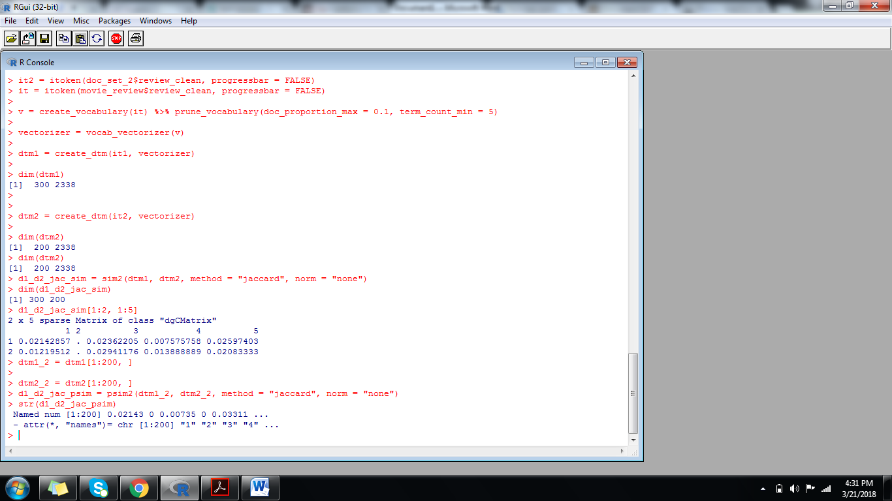

**COSINE SIMILARITY**

> d1_d2_cos_sim = sim2(dtm1, dtm2, method = "cosine", norm = "l2")

> dim(d1_d2_cos_sim)

[1] 300 200

> d1_d2_cos_sim[1:2, 1:5]

2 x 5 sparse Matrix of class "dgCMatrix"

1 2 3 4 5

1 0.02703999 . 0.05063299 0.009500143 0.02753954

2 0.02455143 . 0.06567587 0.034503278 0.04000800

**COSINE SIMILARITY WITHTF-IDF(tern frequency invertd document frequency)**

> dtm = create_dtm(it, vectorizer)

>

> tfidf = TfIdf$new()

> dtm_tfidf = fit_transform(dtm, tfidf)

> d1_d2_tfidf_cos_sim = sim2(x = dtm_tfidf, method = "cosine", norm = "l2")

> d1_d2_tfidf_cos_sim[1:2, 1:5]

2 x 5 sparse Matrix of class "dgCMatrix"

1 2 3 4 5

1 1.000000000 0.007885415 0.02380155 0.02864296 0.01510648

2 0.007885415 1.000000000 0.01120455 . .

>.

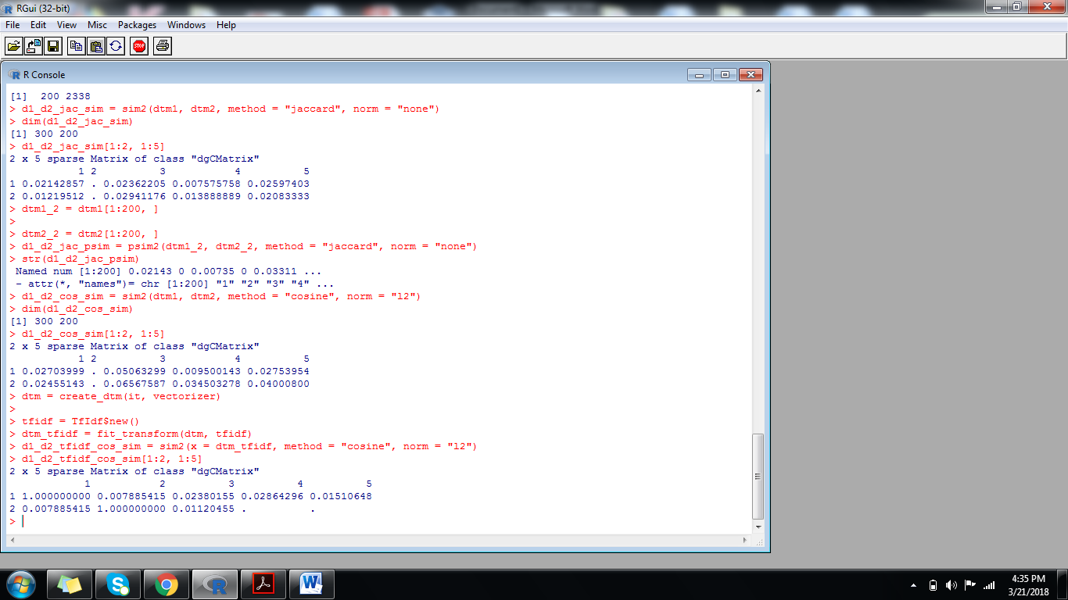

**Cosine similarity with lsa:**

> lsa = LSA$new(n_topics = 100)

> dtm_tfidf_lsa = fit_transform(dtm_tfidf, lsa)

> d1_d2_tfidf_cos_sim = sim2(x = dtm_tfidf_lsa, method = "cosine", norm = "l2")

> d1_d2_tfidf_cos_sim[1:2, 1:5]

1 2 3 4 5

1 1.0000000 0.1131024 0.2441907 0.22305870 0.27371567

2 0.1131024 1.0000000 0.1196754 -0.02698779 -0.04750231

> x = dtm_tfidf_lsa[1:250, ]

> y = dtm_tfidf_lsa[251:500, ]

> head(psim2(x = x, y = y, method = "cosine", norm = "l2"))

1 2 3 4 5 6

0.11315509 0.12302477 0.19959300 0.07237192 0.18237174 0.02230621

>

